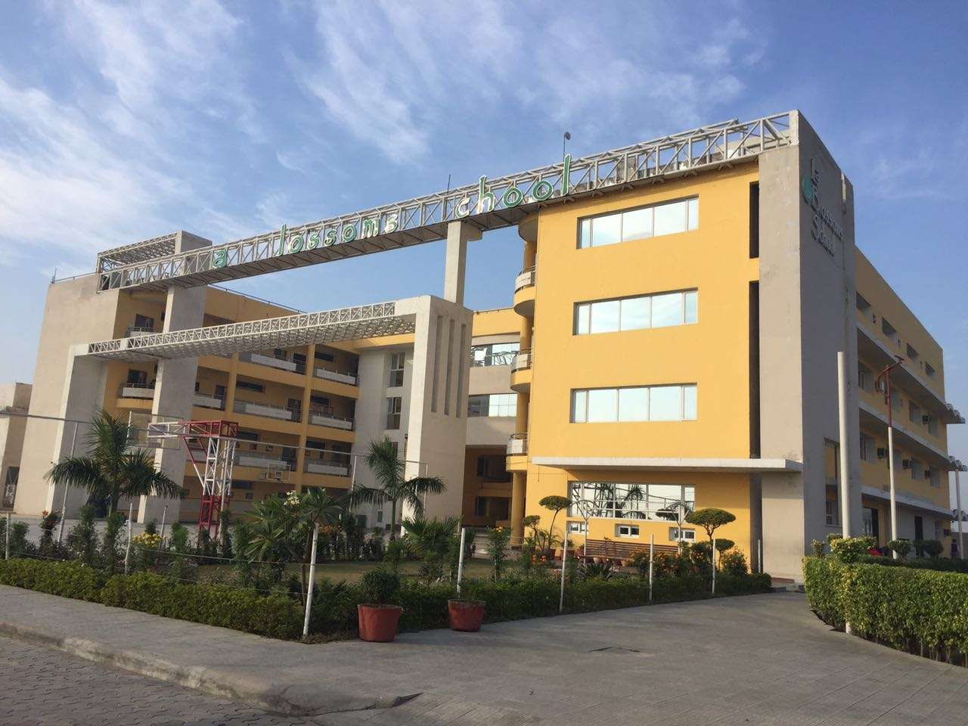
LA BLOSSOMS SCHOOL
SCHOOL REPORT
SESSION 2021-22

“Education is the key that unlocks the golden door to freedom.” —George Washington Carver

With the situation turning normal and a blend of offline and online mode, the challenge was to deal with the psychological issues faced by the students. LBS was prepared to handle it one step at a time. We believed in experimenting new things, staying in touch with our stakeholders for feedbacks while simultaneously changing the expectations of the educationists and the parents. We knew the focus and the ways will have to be innovated and regular meetings/discussions with the experts and school faculty helped implementing a system that has garnered lot of praise.

LBS Planning Guidelines for Managing Student Learning focusing more on physical and mental health

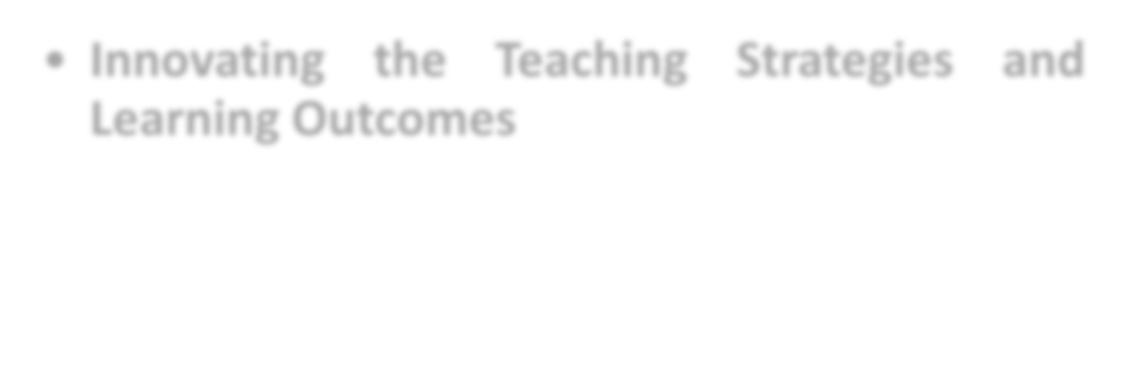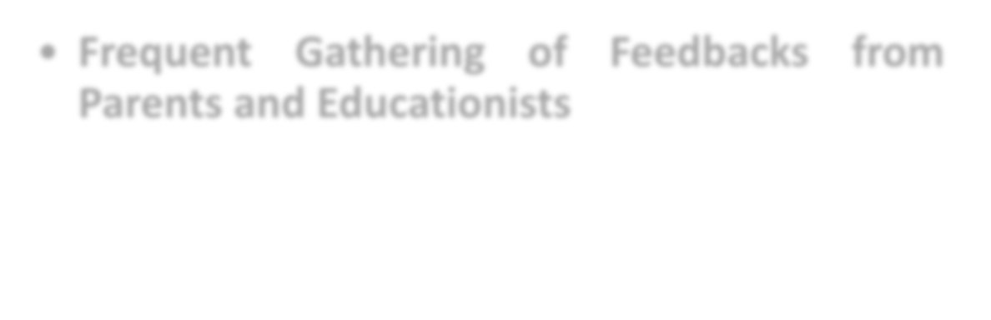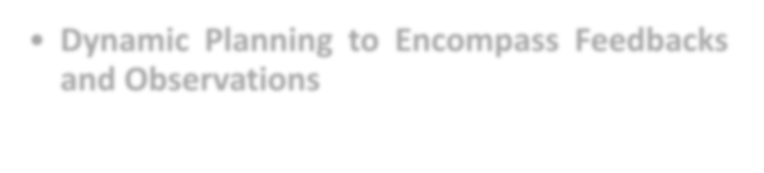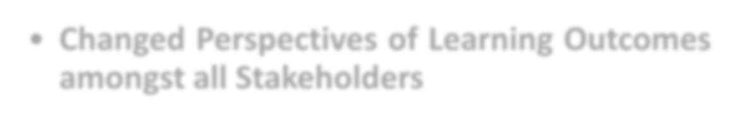• Innovating the Teaching Strategies and Learning Outcomes
- • Frequent Gathering of Feedbacks from

Parents and Educationists
- • Dynamic Planning to Encompass Feedbacks and Observations

Holistic Development of Blossomites
through Innovative Mediums

Cognitive Development

Physical Development

Creative Development

Language Development

Emotional Development

Message from Director’s Desk

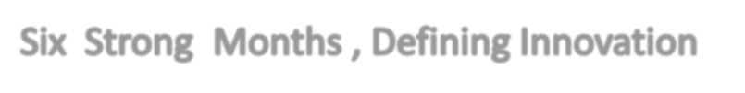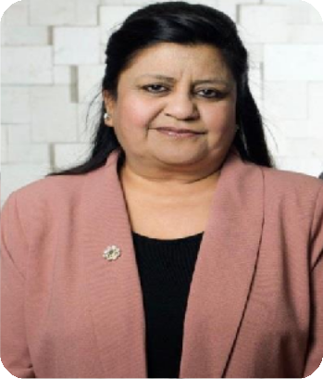

We believe it is also valuable to look beyond these immediate concerns to what may be possible for education on the other side of the COVID-19 pandemic. It is hard to imagine there will be another moment in history when the central role of education in the economic, social, and political prosperity and stability of nations is so obvious and well understood by the general population. Now is the time to chart a vision for how education can emerge stronger from this global crisis than ever before and propose a path for capitalizing on education’s newfound support in virtually every community across the globe.
It is in this spirit that we have developed this report. We intend to start a dialogue about what could be achieved in the medium to long term if leaders around the world took seriously the public’s demand for safe, quality schools for their children. Ultimately, we argue that strong and inclusive public education systems are essential to the short- and long-term recovery of society and that there is an opportunity to leapfrog toward powered-up schools.

Nurturing Individuals-Our Mission

As the Directors , we definitely did not have answers to all the questions since the situation was new for us as well and as an organization we too were navigating the restrictions imposed on us . However, at this stage we intended to interact with our stakeholders to uplift their morale and take feedback on the initiatives taken by us.

On the way, several factors drew our attention like, screen time , challenges of working parents, internet bandwidth, security of children . Each day has been a new learning experience and with the support of our parents we have been constantly evolving . In fact it will not be an exaggeration if we say that parental suggestions have become catalyst to create the new effective methods of teaching .

This is one of the major reasons that in these unprecedented times we maintain flexibility in our teaching methodologies and this gives us the liberty to explore and utilize our resources skillfully.

As educators we are constantly empowering our students and equipping them to stay abreast in the coming sessions. Displaying excellence by defeating fear , we are proud of delivering continuous and progessive Online and Offline Education .

CELEBRATIONS
Mother’s Day

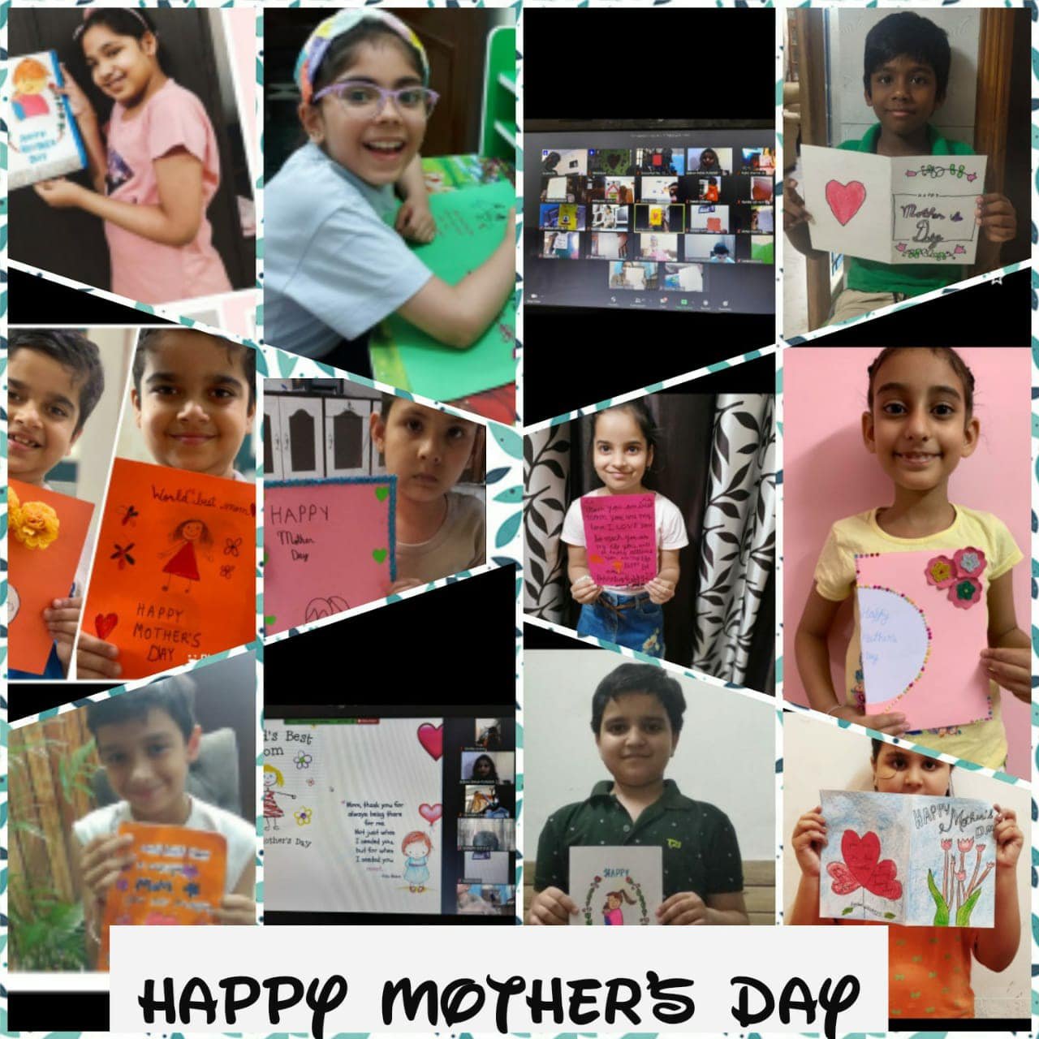

World Environment Day
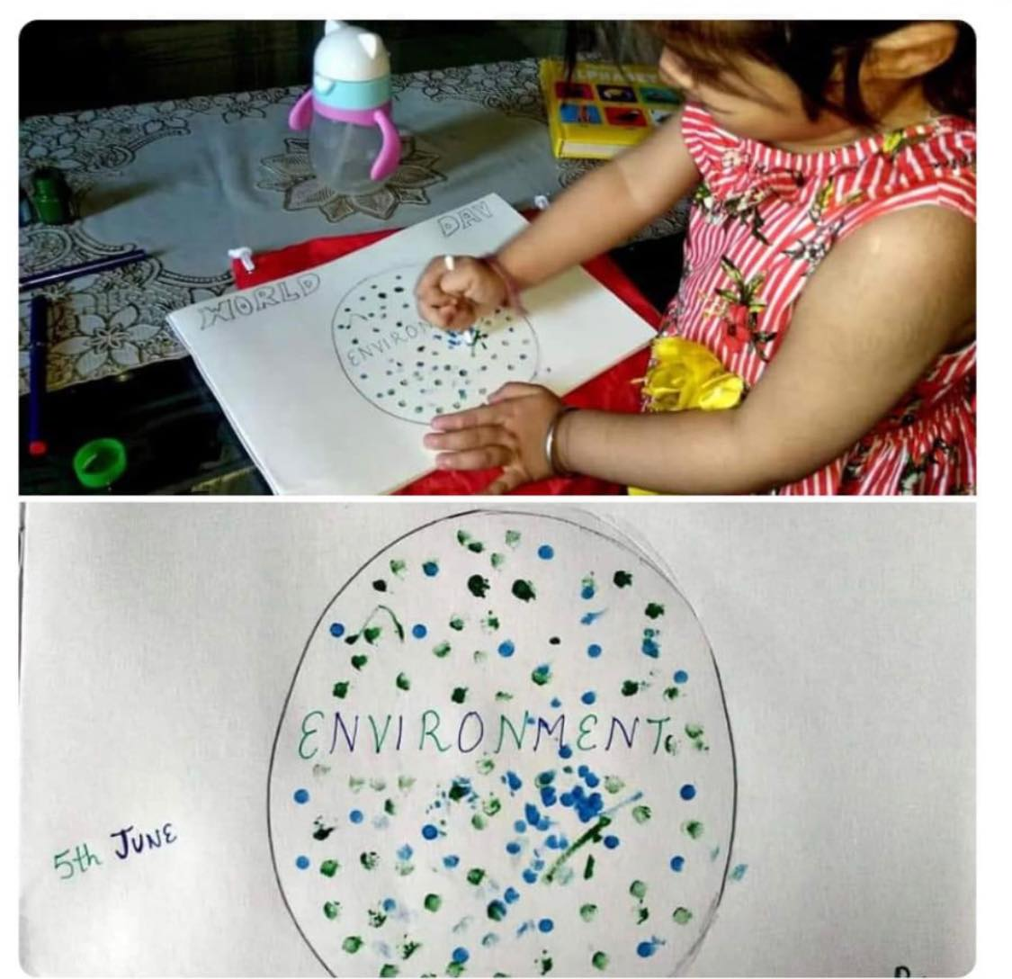

Raksha Bandhan and Independence Day

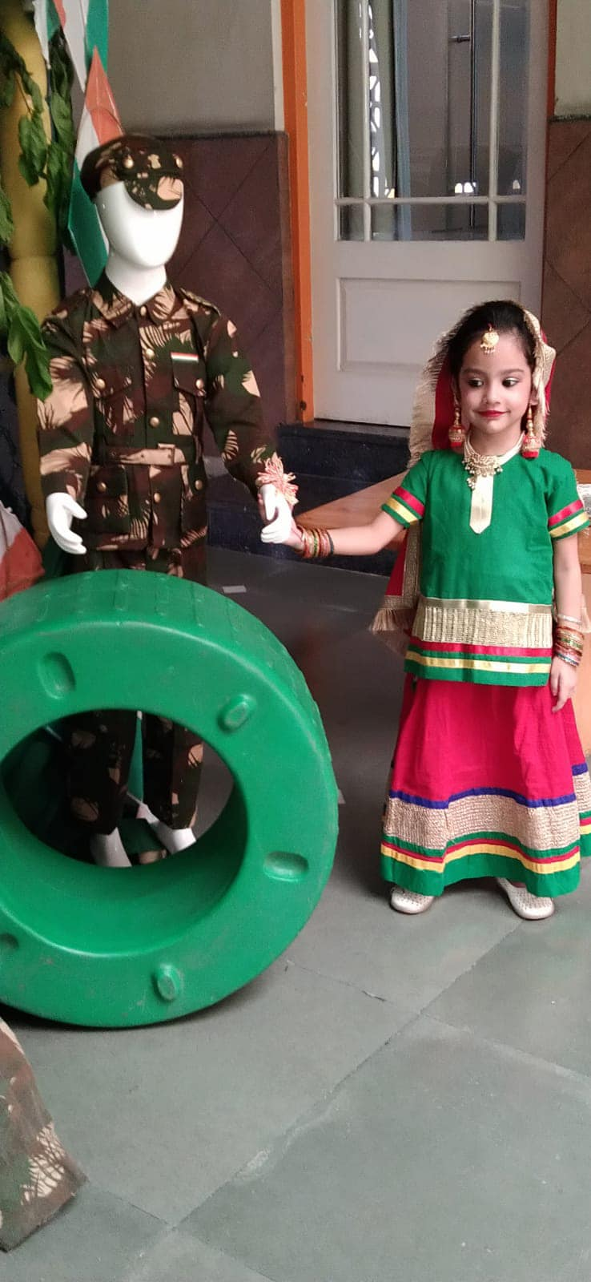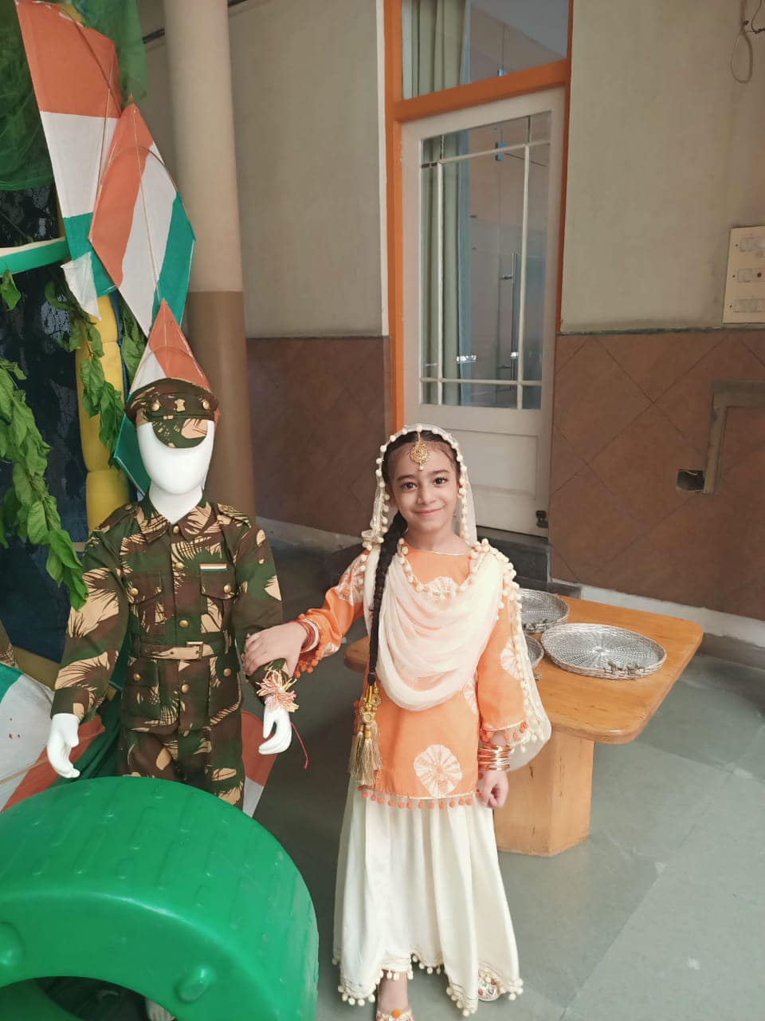

Grandparents’ Day
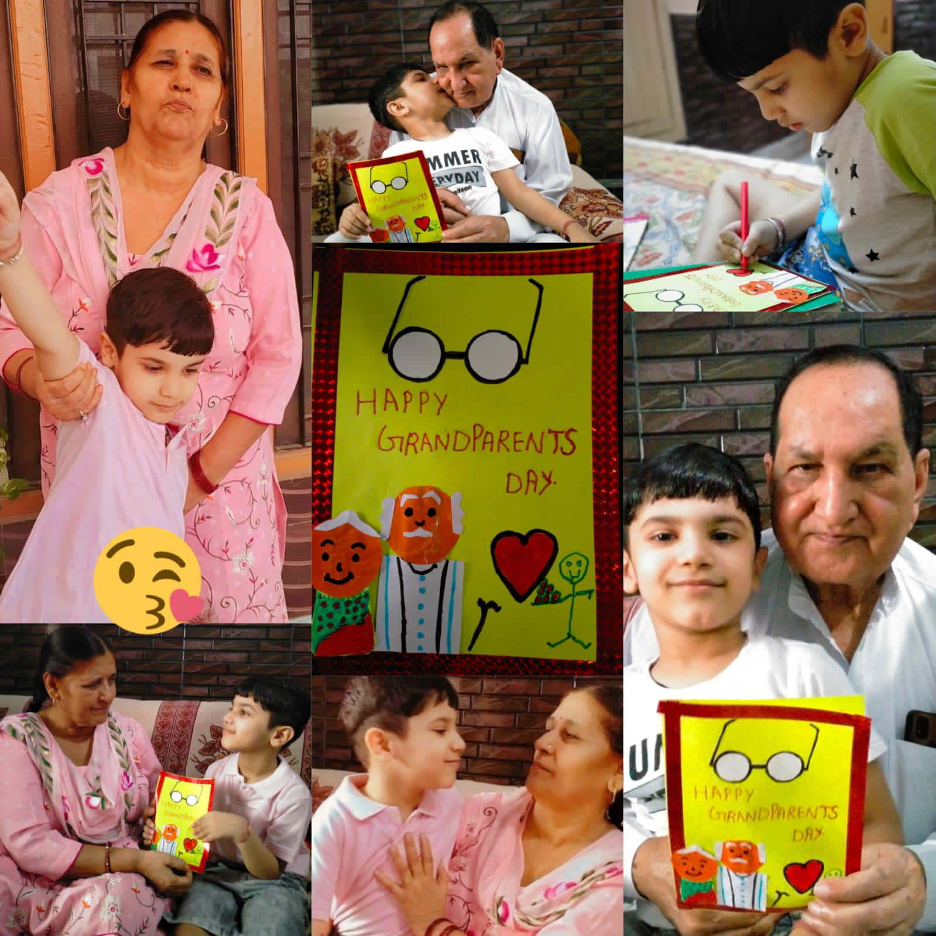

FAREWELL PARTY

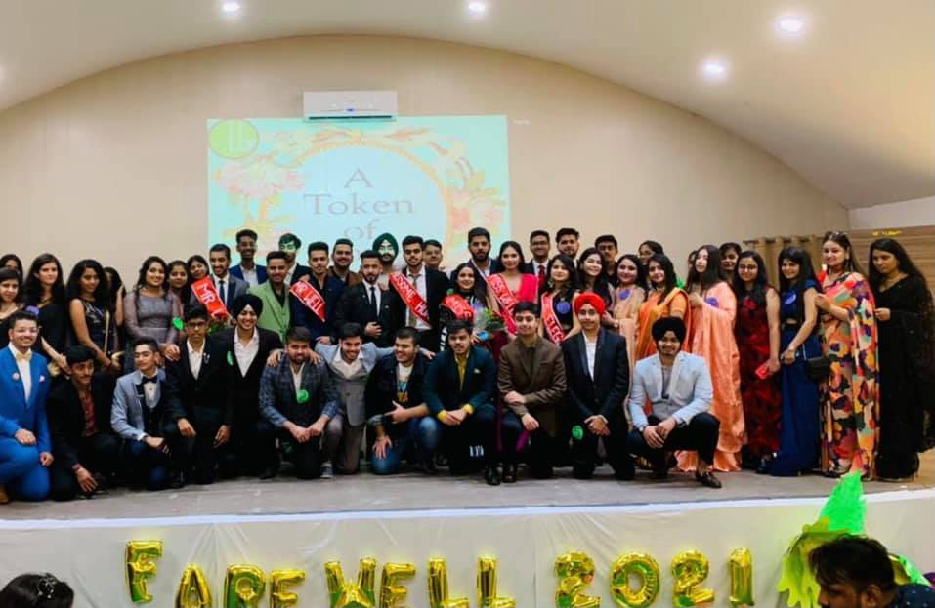
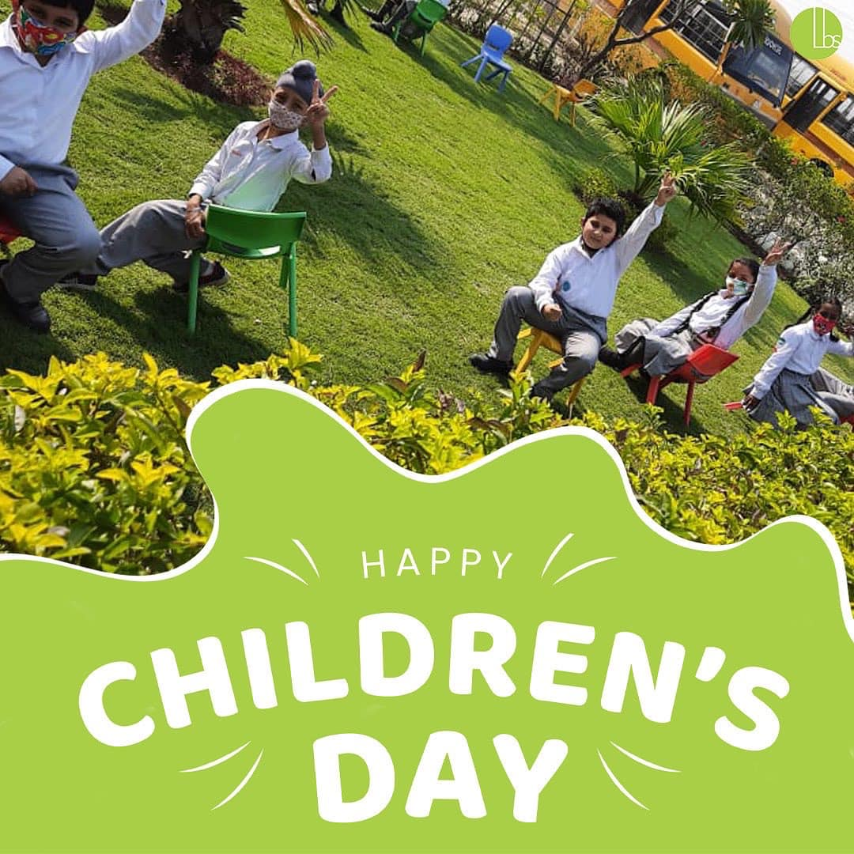
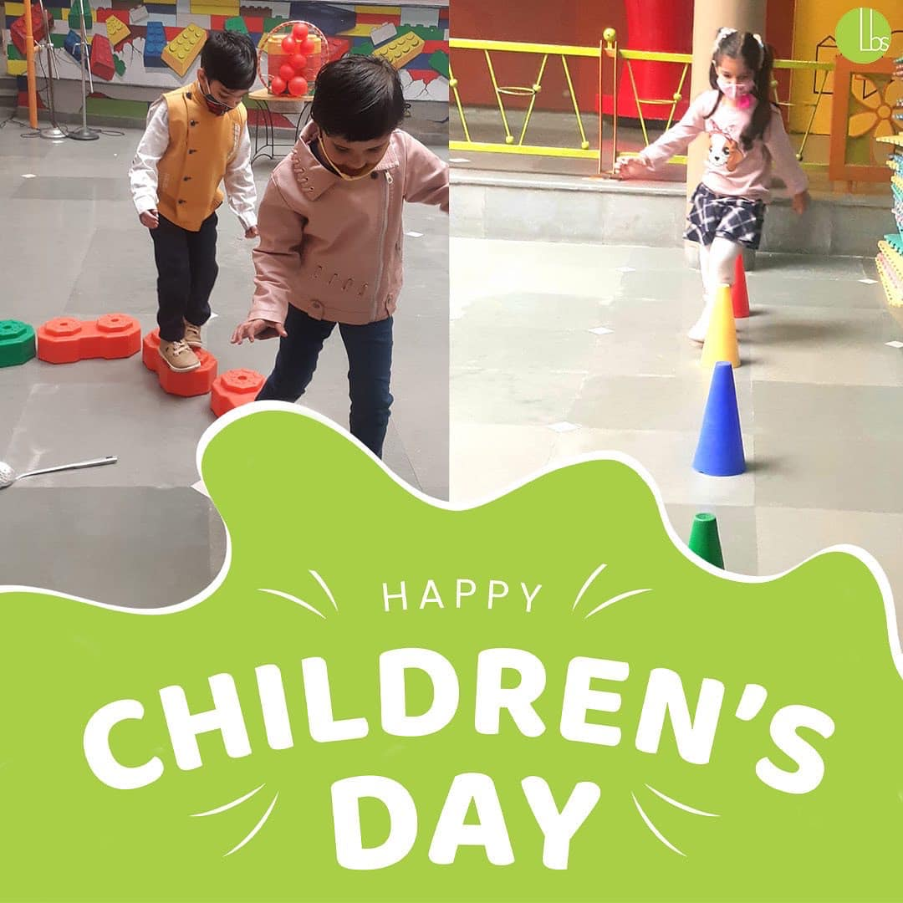
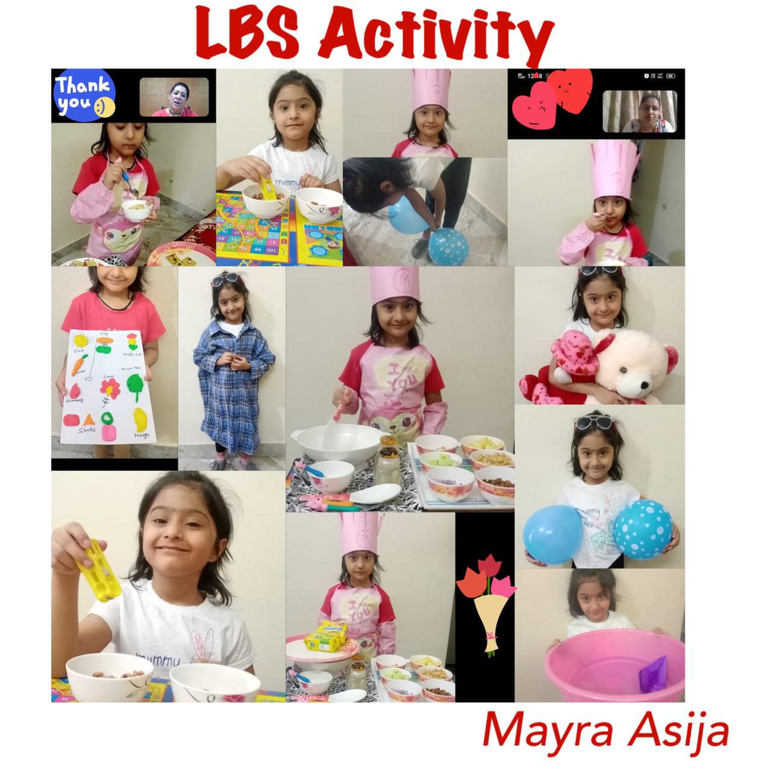
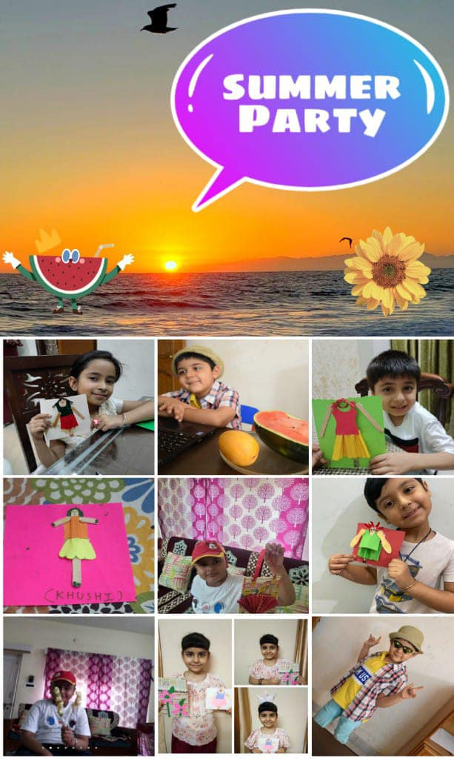
Mock Parliament Session
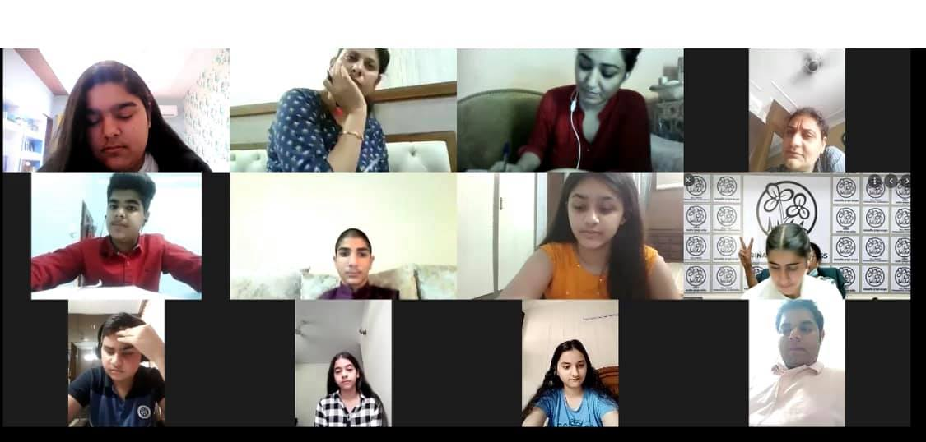

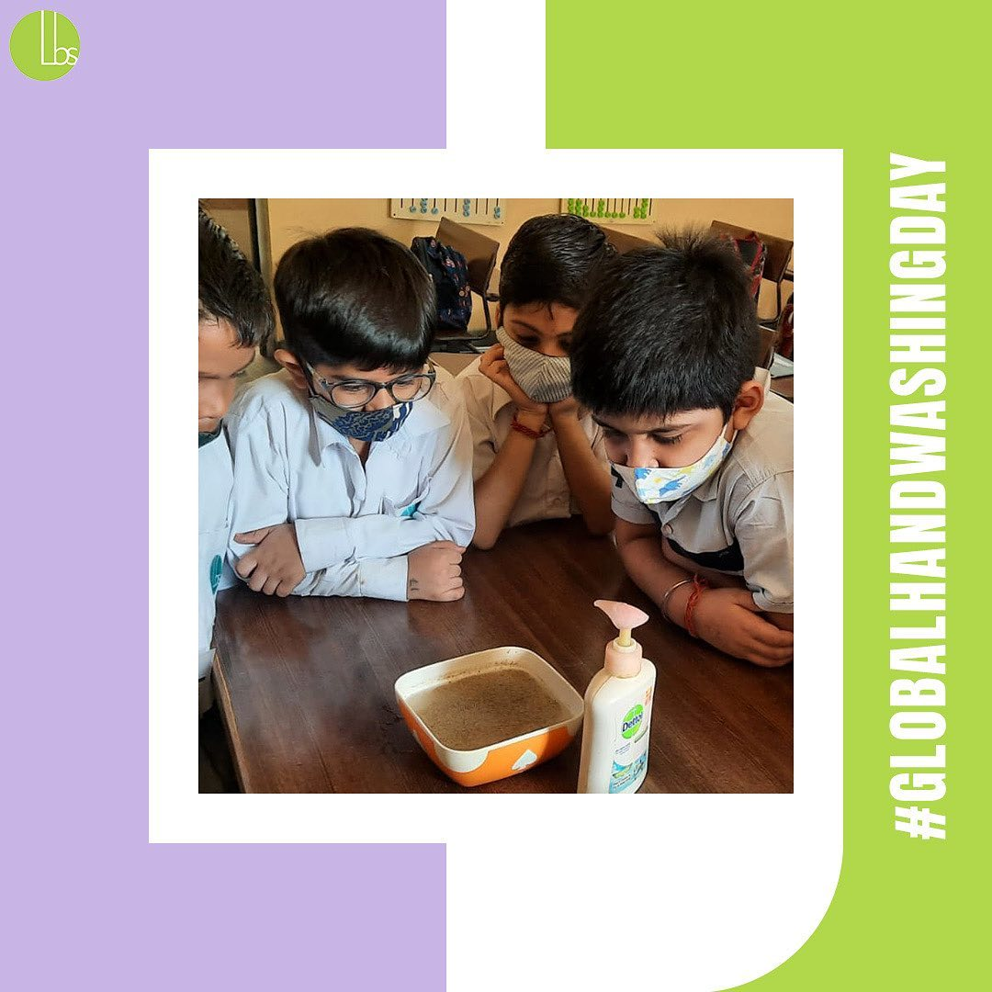
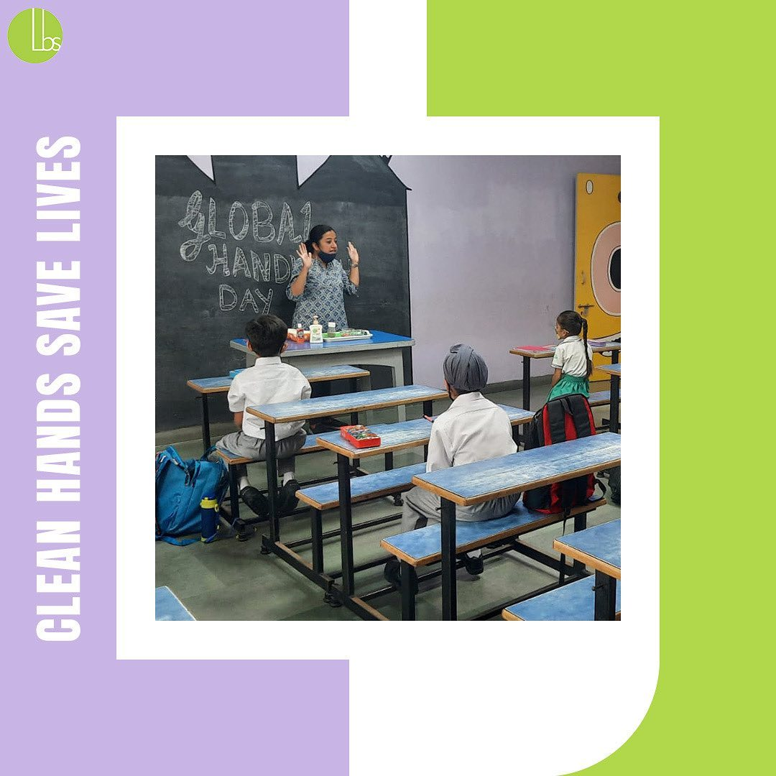
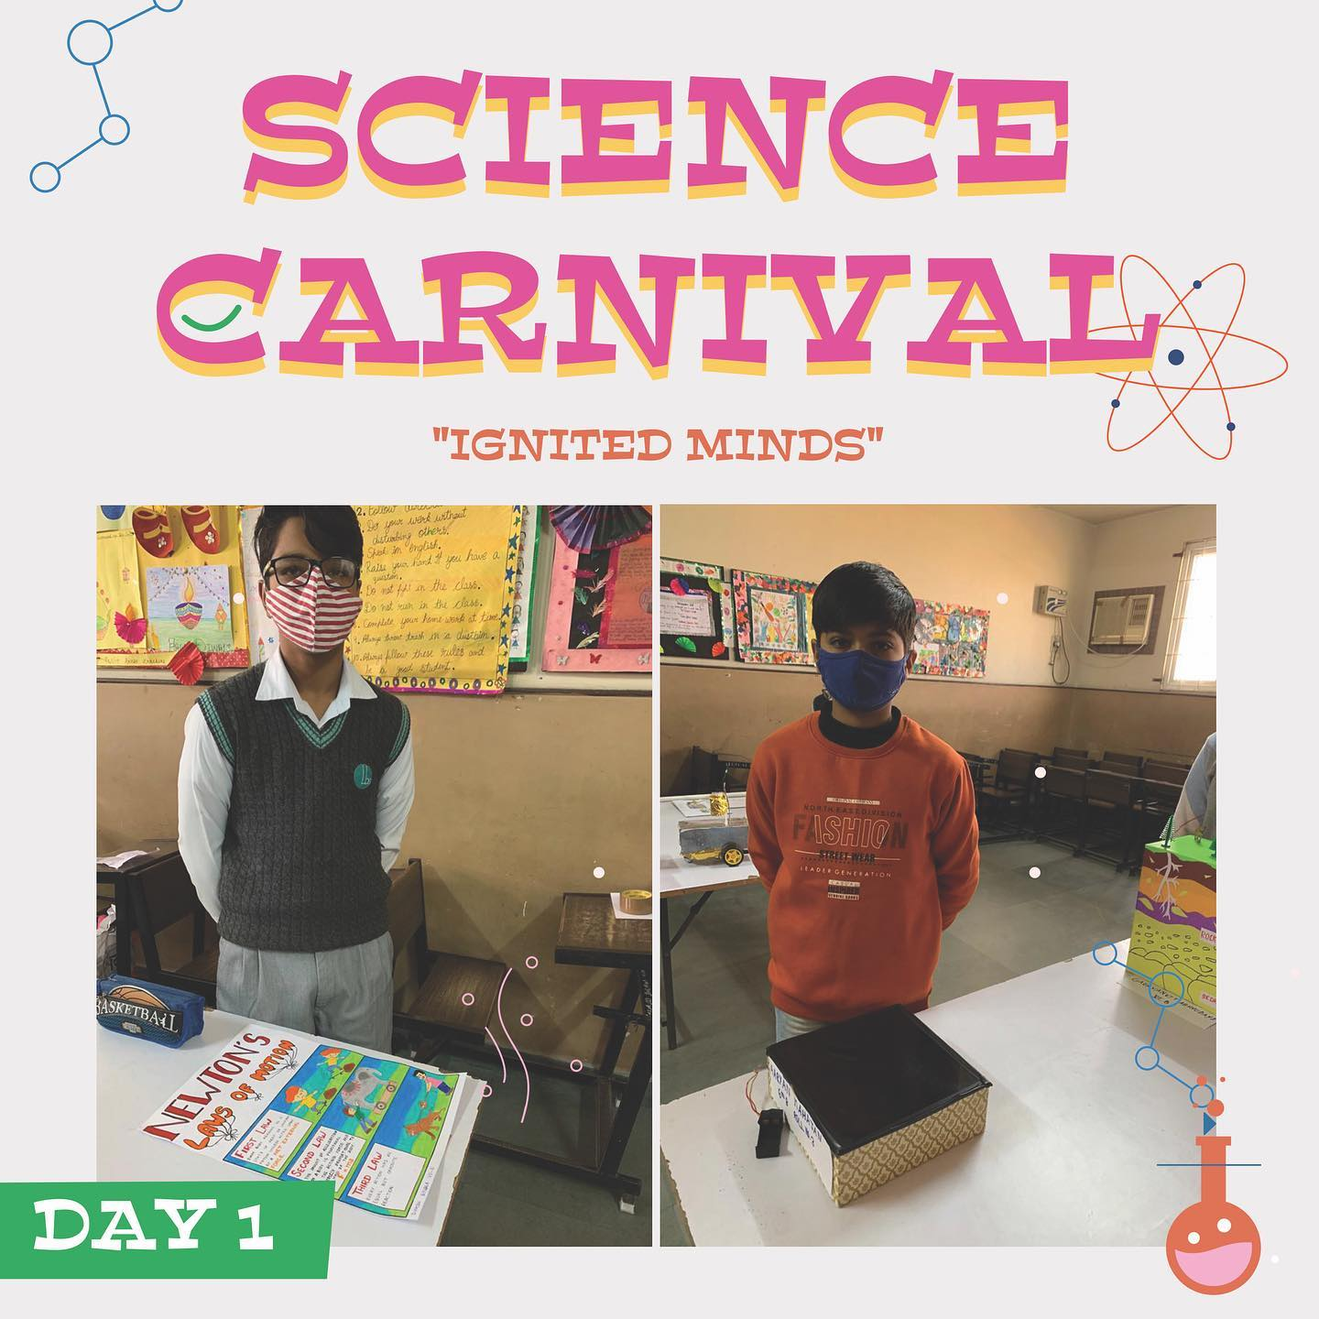

Achievements
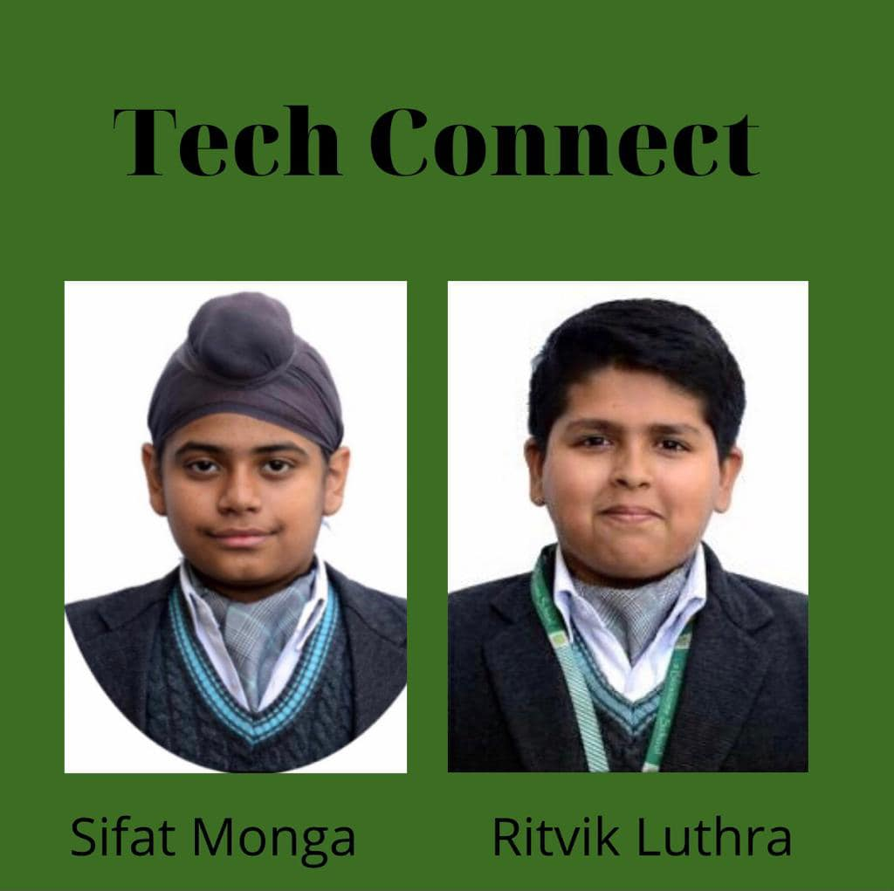

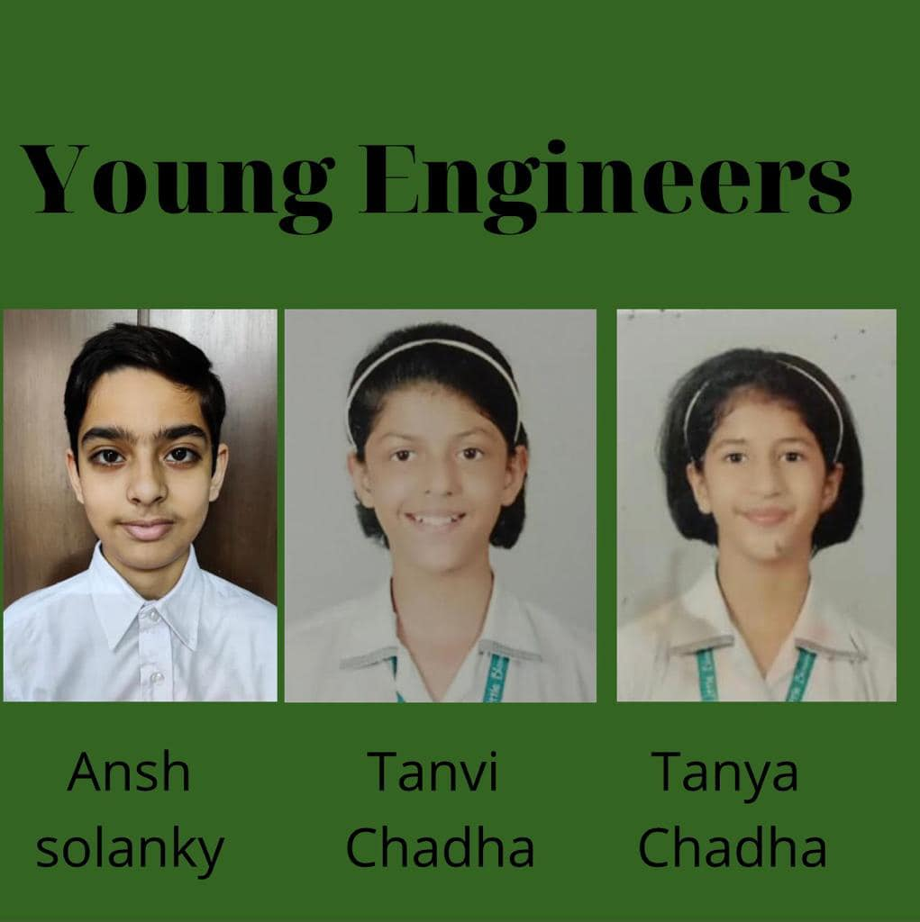

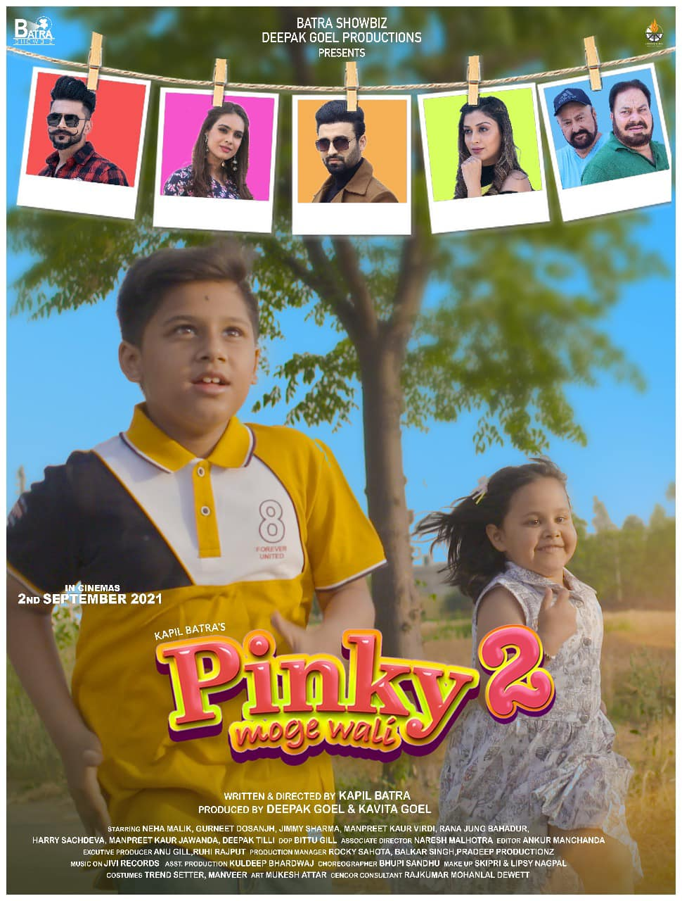
Arisha Mittal (Class LKG)made us proud with her lead role in Movie
“Pinky Moge Wali”.
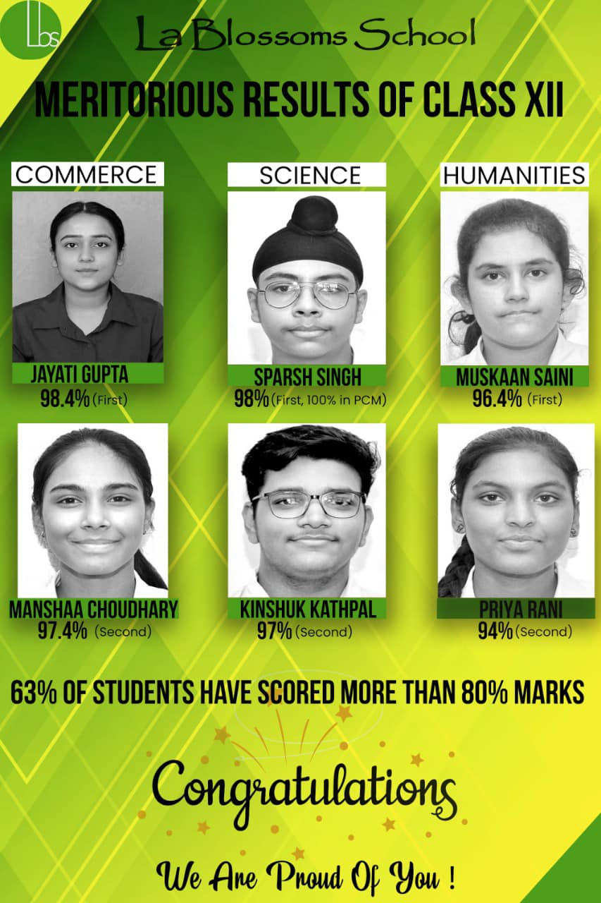
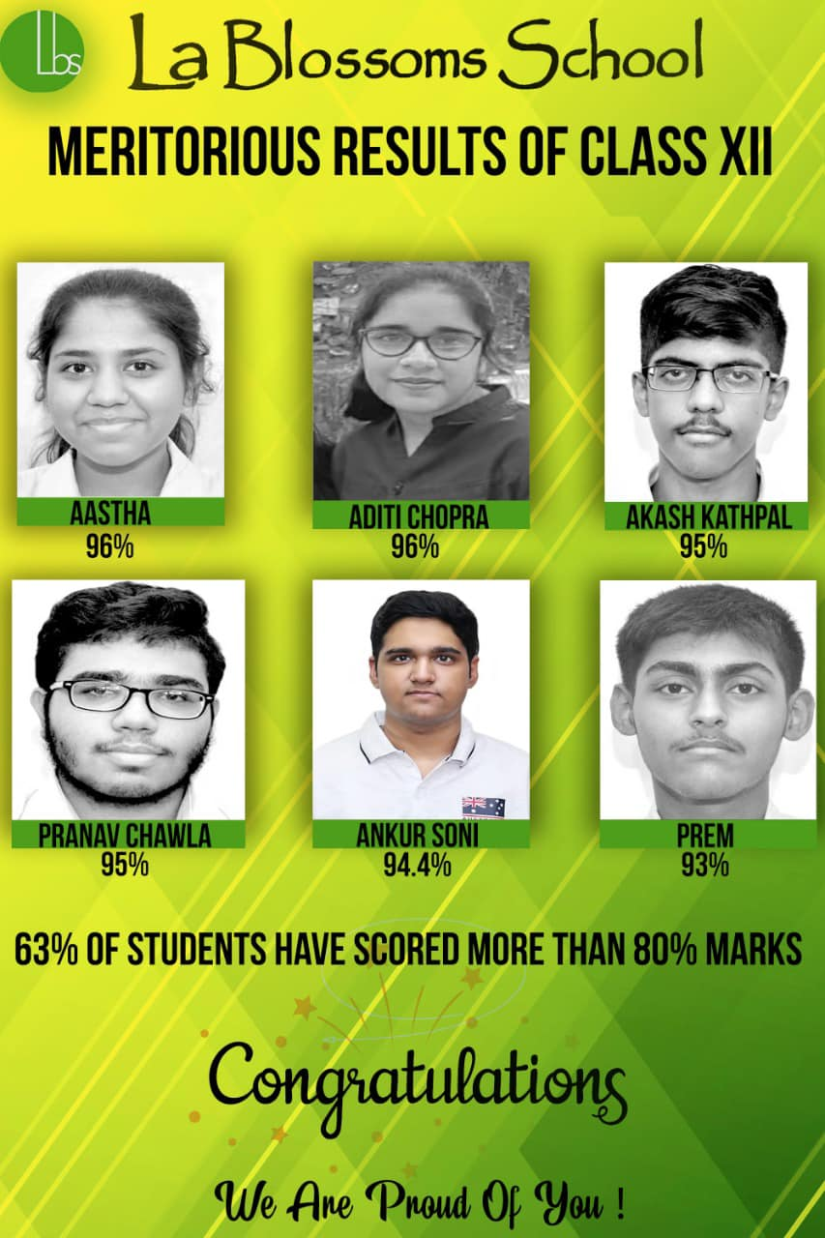
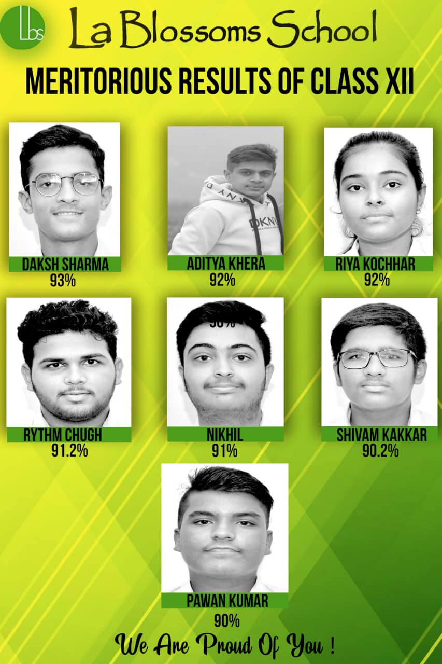
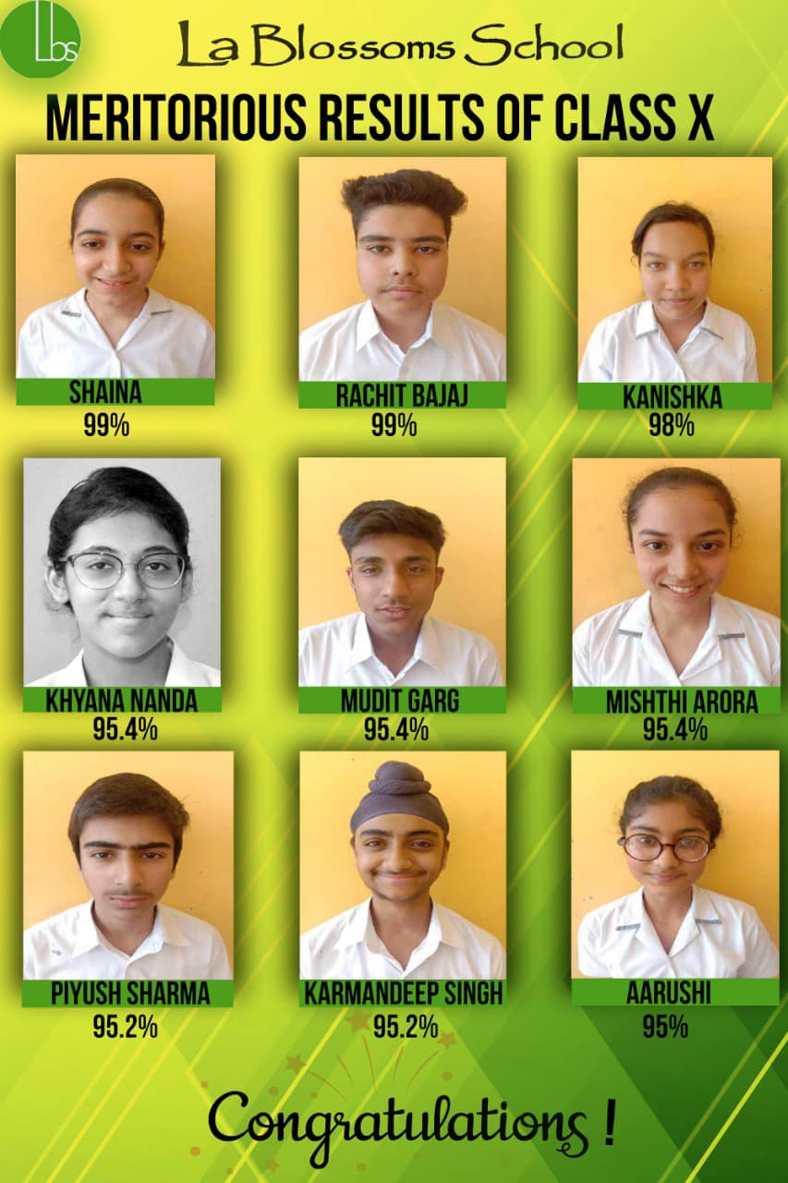
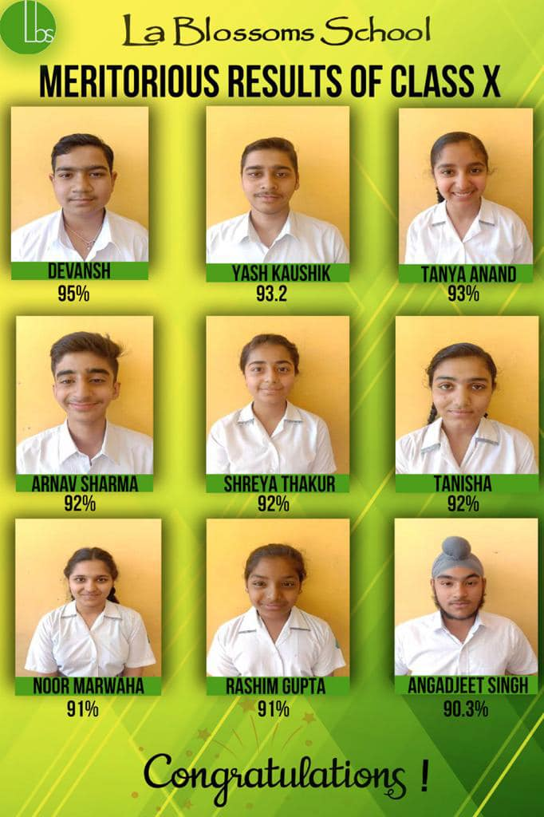
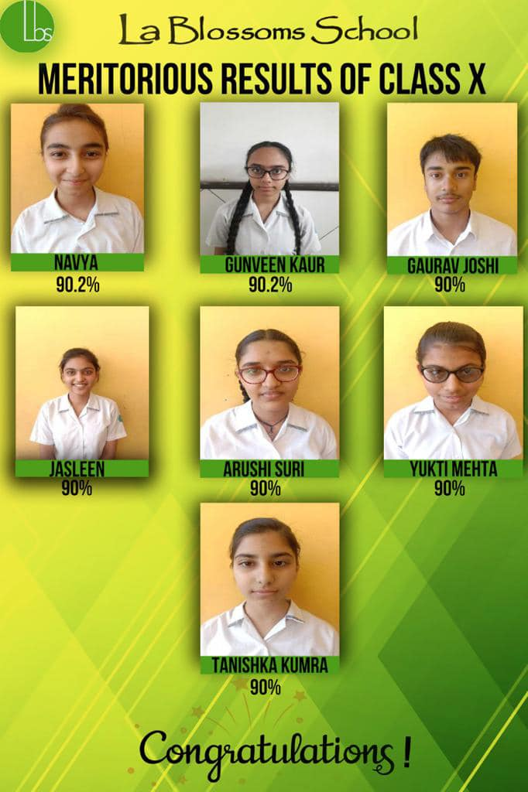
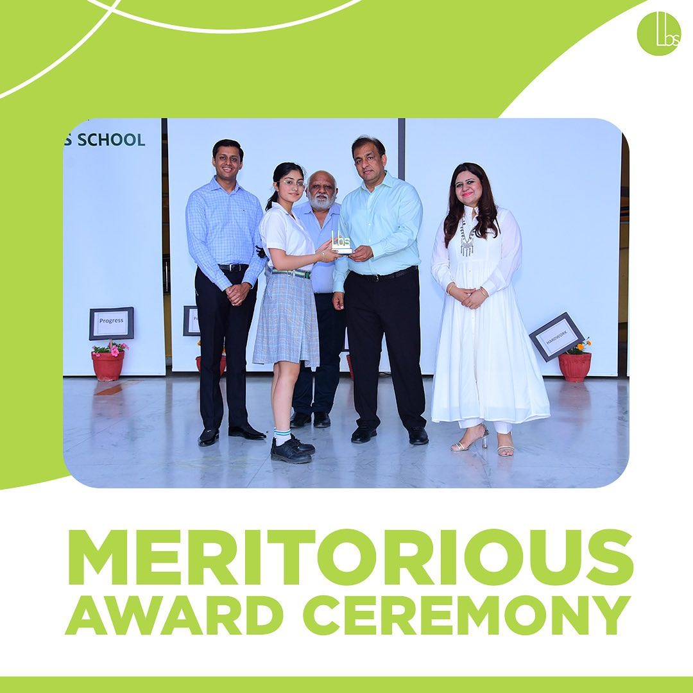
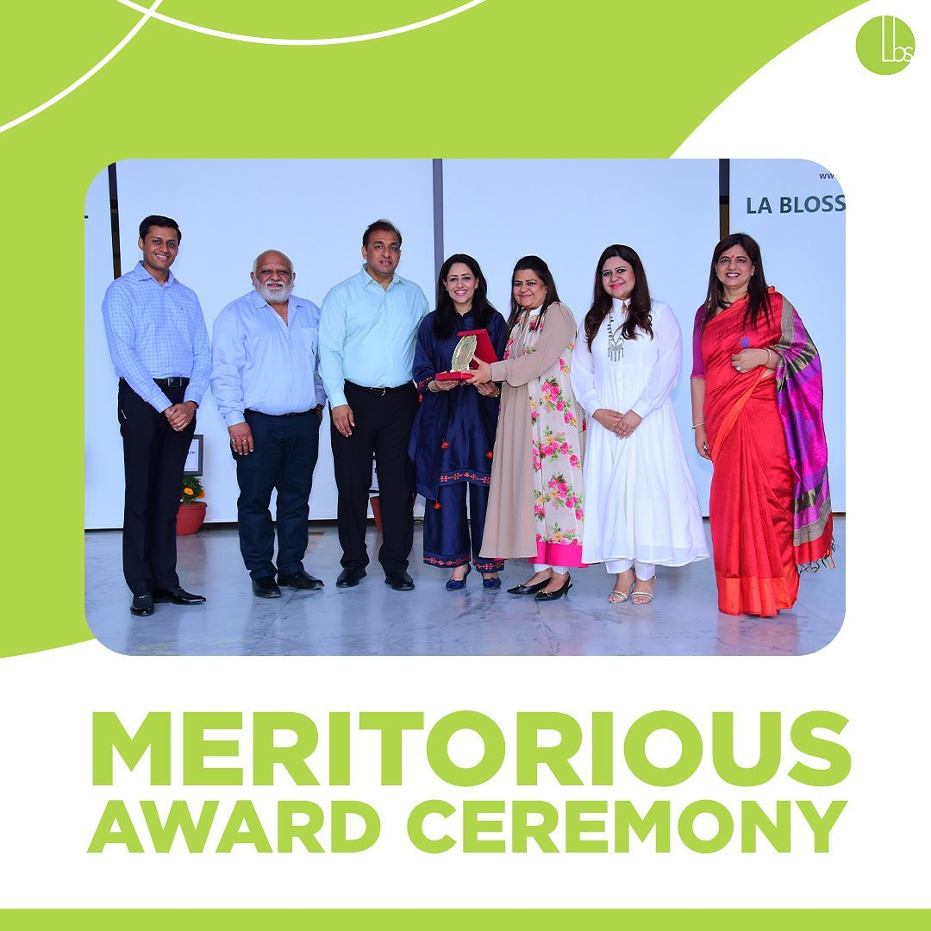

SPORTS ACHIEVEMENTS (2021-2022)

GAME | EVENT | PLAYERS NAME | ACHIEVEMENTS
JUDO | PSEB DISTT | VIYOM SETHI | GOLD
 | PSEB STATE | VIYOM SETHI | SILVER
 | OPEN DISTT | SHIVEN | SILVER
 | OPEN DISTT | NAKUL ARORA | GOLD
 | STATE |  | GOLD
 | OPEN NATIONAL |  | GOLD
LAWN TENNIS | DISTT SAHODYA | HARSHAUN | GOLD
 | DISTT SAHODYA | KARANDEEP | GOLD
 | DISTT SAHODYA | HARSHDEEP | GOLD
SKIPPING | PSEB STATE | SAKSHAM | GOLD
BADMINTON | DISTT OPEN | SAKSHAM | SILVER
 | OPEN DISTT | AKSHIT | PARTICIPATION
 | PSEB STATE | KUNWAR | PARTICIPATION
 | OPEN STATE | TUDBEER | PARTICIPATION
CRICKET | DISTT OPEN | AKS | PARTICIPATION
 | DISTT | HITYANSH | MAN OF THE MATCH
 | DISTT | ANMOL CHOUHAN | PARTICIPATION
 | DISTT OPEN | ANHAD | SECOND
 | DISTT OPEN | HARMAN | PARTICIPATION
 | DISTT OPEN | YUVRAJ | PARTICIPATION
KICK BOXING | DISTT | SAKET BEDI | GOLD
KARATE | STATE | SAKET BEDI | GOLD
 | NATIONAL | SAKET BEDI | SILVER
 | OPEN DISTT | HITYANSH | GOLD
 | STATE | HITYANSH | GOLD
 | NATIONAL | HITYANSH | SILVER
THROW BALL | DUBAI DISTT | RYTHEM | GOLD
SHOTPUT | DUBAI DISTT | RYTHEM | GOLD
SKATING | DISTT | BHAVYA | GOLD
 | STATE | BHAVYA | PARTICIPATION
HOCKEY | OPEN DISTT | RANVEER | THIRD
 | PSEB DISTT | RANVEER | PARTICIPATION

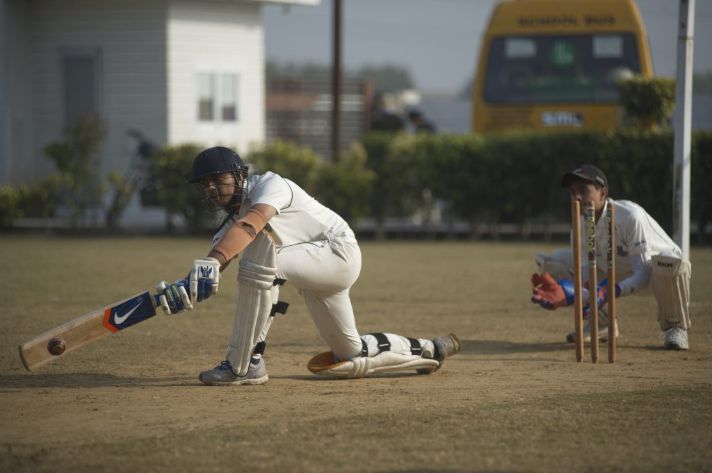
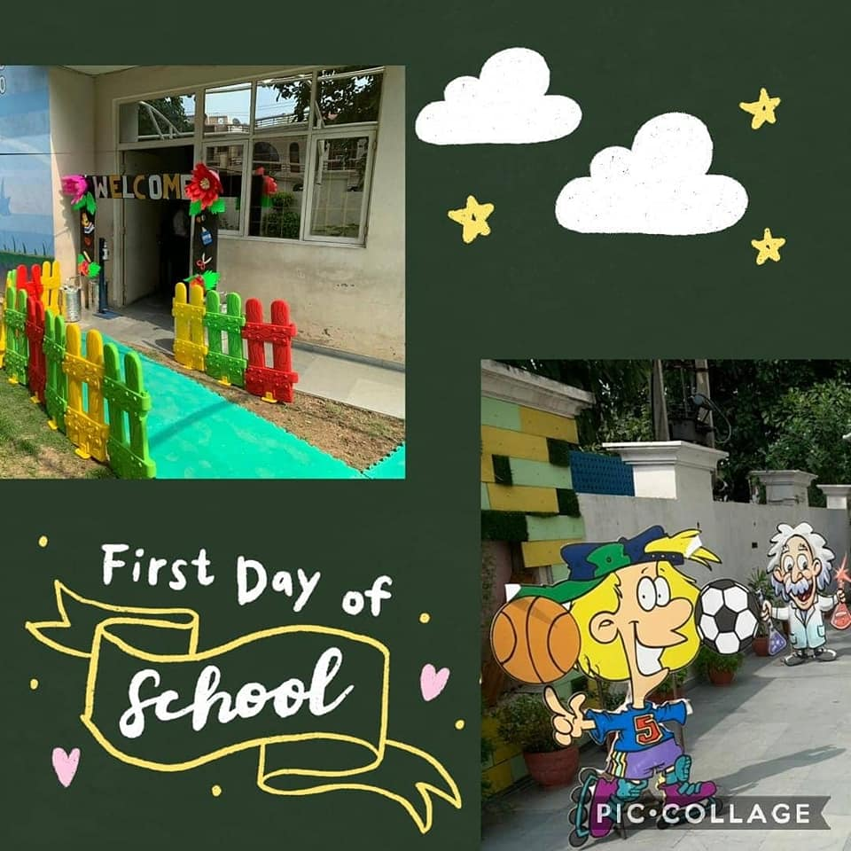

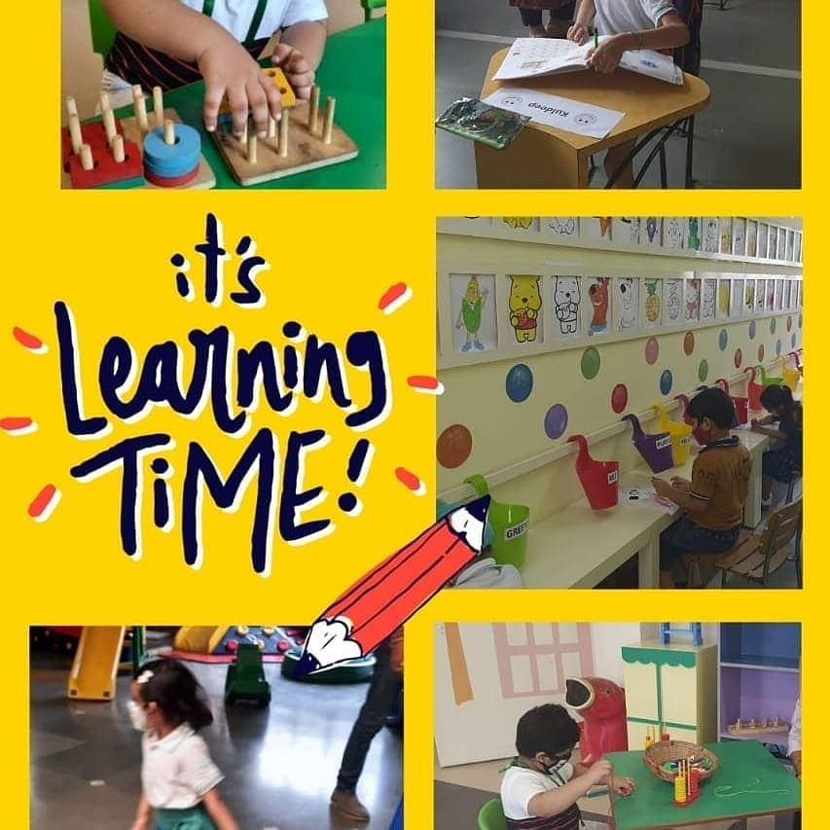

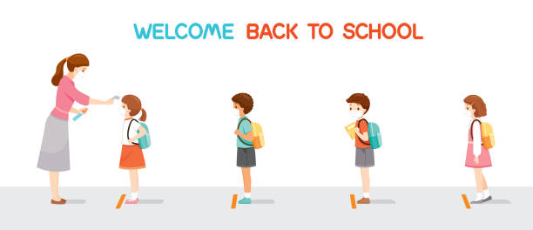

Looking forward to a healthy and COVID free school environment
WITH CHEERFUL FACES ALL AROUND

