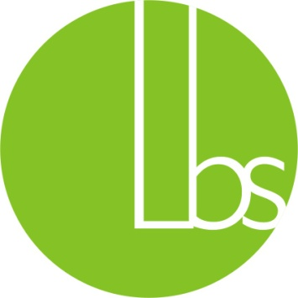
LBS Scholarship Test 2018

LBS has always believed in motivating its students through awards and appreciation. LBS Scholarship Test is an initiative by the School Management to encourage and appreciate students with strong academic abilities though cash prizes and certificates. This test will be held every year for students of classes 4th to 10th and the awards will be distributed in the next academic session. The details of the test are as follows:
Open for: LBS students of classes 4rd to 10th, Outsiders (Aspiring Students) of classes 8th to 10th
Date: To be confirmed
Time: 11 AM
Venue: La Blossoms School, South City, Jalandhar
Duration: 90 minutes
The test will have a total of 60 multiple choice questions from the following sections: English(10), Science(20), Mathematics(20), Aptitude(10). The questions will be based on the concepts covered by the child in the present class. Prizes based on LBS Scholarship Test will be as follows:
Class | Rank | Scholarship
4rd to 7th  ^{Only LBS Students} | 1 | Rs 2500*
 | 2 | Rs 1500*
 | 3 | Rs 1000*
8th to 10th  ^{LBS & Aspiring Students} | 1 | Rs 5000 + 40% Concession in Tuition Fee *
 | 2 | Rs 3000 + 30% Concession in Tuition Fee *
 | 3 | Rs 2000 + 20% Concession in Tuition Fee *
*Will be awarded if the student scores a minimum of 90% marks in aggregate and 80% marks in each subject. The student will also be required to score a minimum of 85% marks in Term 1 for continuation of scholarship in form of fee waiver.
The toppers will also be awarded medals of excellence.
Please register your child for the scholarship test by filling the Scholarship form available on the school website. Last date of submission: January 15, 2017.

