LBS
SA – I
CLASS III (2015-16)
ENGLISH
Time: 2:30 hrs M M:50
Section A (Reading)
Read the following and answer the following questions:
Mahatma Gandhi was born on October 2, 1869 in Porbandar, Gujarat. His real name was Mohandas Karamchand Gandhi. His mother’s name was Putlibai and his father’s name was Karamchand Gandhi. At the age of 13 he was married to Kasturba. At 19, he was sent to England to study law. He fought against injustice against Indians and Africans in South Africa in 1893. He fought through peaceful and non violent methods. On his return to India, he fought against the British and forced them to leave country. On January 30, 1945, he was shot dead by Nathuram Godsey. Gandhiji is popularly called ‘ Bapu’or the ‘Father of the Nation’.
A1. Choose the correct option: (5)
- Mahatma Gandhi was born on
- 3 September 1869 b. 2 October 1869 c. 1 December 1900
- Gandhi’s real name was______________
a. Karamchand Gandhi b.Mohan Das Karamchand Gandhi
c. Putlibai
- His Wife’s name was ________________
a. Kasturba b. Sita c. Mirabai
- He went to study law in _____________
a. England b. Japan c. South Africa
- Gandhiji was shot dead on___________
a. 30 January 1948 b. 31 January 1947 c. 30 June 1945
A2. Write True or False:
- Gandhiji’s policies forced the British to stay in India.
- Gandhiji is known as the Father of the Nation.
A3. Pick out two proper nouns from the passage.
A4. Make sentence of ‘study’.

Section B (Writing) (6)
B1. Write a letter to your friend telling her/him about a pet you bought recently. {Hints – Which animal it is; dog, cat, name of the pet, colour, size, place where you keep it, what you do together etc}
Or
B2. Look at the picture given below. Write a paragraph with the help of hints given:

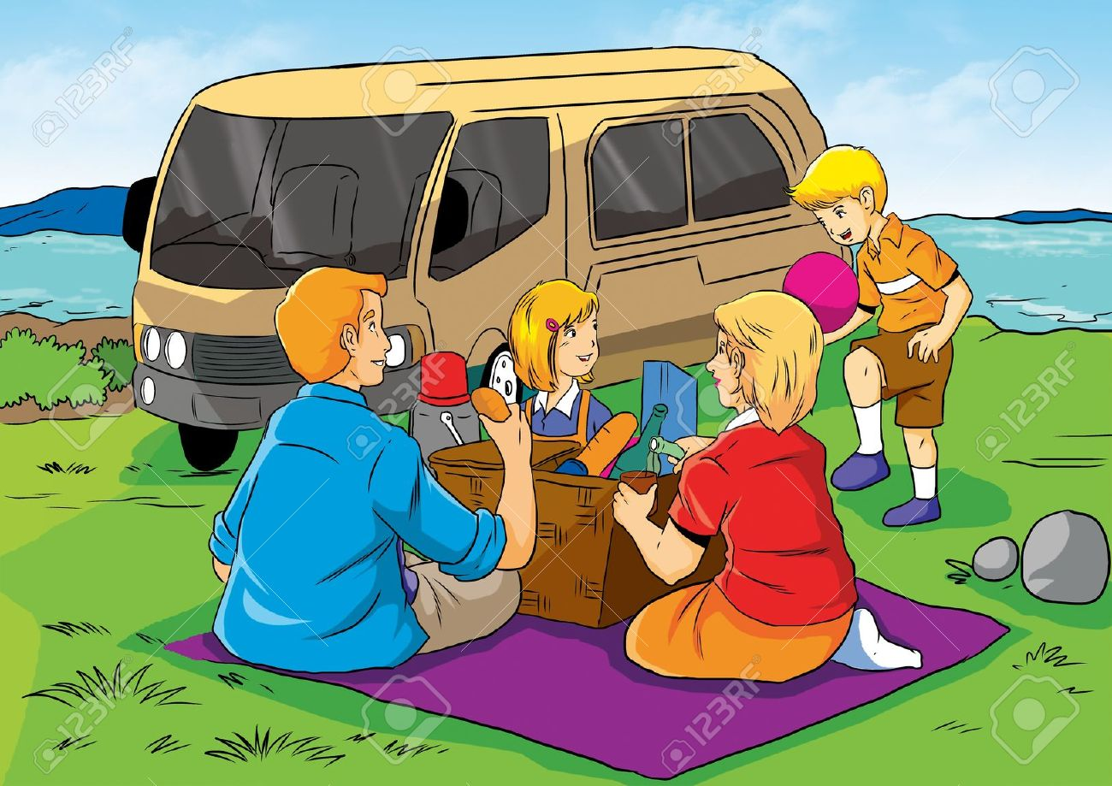

{Hints – bright sunny day, family, picnic, riverside, basket, eatables, van, thermos, ball, mat, greenery etc.}

Section C (Grammar)
C1. Rearrange these group of words to form simple sentences: (2)
- Seven are in colours rainbow there a
- Birbal was minister a wise
C2. Underline the common nouns and circle the proper nouns: (2)
- My sister knows French.
- The Nile is a very long river.
C3. Rearrange the words to form questions: (2)
- The train has left the station
- Is your birthday party when
C4. Fill in the blanks with a, an or the: (2)
- This is not ____________ easy question.
- Fiza is _______________best student in our class.
- _________ ant is ___________ tiny insect.
C5. Fill in the blanks with is, am or are: (2)
- Hary __________ the monitor of his class.
- The children _____________ making cards.
- I _____________ going to the park.
- You ____________ my best friend.
C6. Punctuate the following sentences: (2)
- I bought some eggs cheese fruits and vegetables from the market
- sania mirza is playing in mumbai
C7. Choose the correct option: (3)
- I __________ (visit/visits) my uncle at weekends.
- My father ____________ (work/works) in a bank.
- The sun _________ (shine/shines) during the day.
- They are ____________ in the garden. (play/playing)
- We are __________ (go/going) to the zoo.
- We _________ not eat fish. (do/does)

Section D (Literature)

D1. Answer the following. [Any 4] (10)
- What idea did uncle Venu give to the children?
- What advice did the hakims give to the emperor?
- Who was Birbal? Describe his two qualities.
- Why did uncle Venu scold the children? Who fell on the staircase?
- Name three things that Gita had for breakfast.
D2. Give the meanings of the following words and frame them into sentences: (3)
- rude b. idea c. bothered
D3. Give opposites of: (2)
a. cheerful b. sweet c. quickly d. smile
D4. Unjumble the following stanza and write the name of the poem and the poet: (5)
More than 700 poundson its plate
Plus a mouth that can eat
with jumbo – sized feet,
over five tons is its weight!
The elephant surely is great!

D5. Choose the correct option: (3)
- Gita got a cup of milk with a little ___________ in it
a. tea b. coffee c. honey
- Gautam’s idea was to ring a doorbell and _______________
a. stand b. run c. jog
- __________ told Akbar to take rest and medicines.
a. Hakims b. Ministers c. Birbal
- Akbar was not ____________ with the storytellers because their stories came to an end
a. happy b. sad c. angry
- Arjun wants to ________ a new pencil
a. by b. buy c. bye
- Children in the story ‘The Kid’s Club’ lived in ___________.
a. China Apartments b. Bharat Apartments c. Delhi Apartments

D6. Who said these words to whom? (2)
- Oh! Gautam’s fallen and hurt himself.
- I am so bored! I have nothing to do.

